Cultural tour

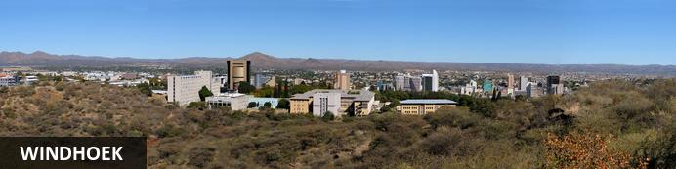
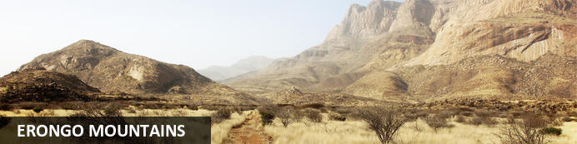
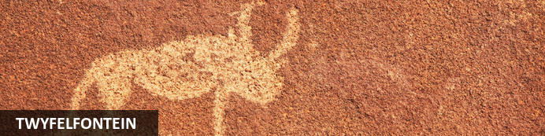
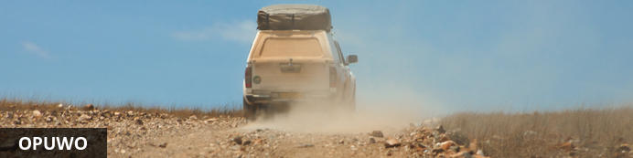
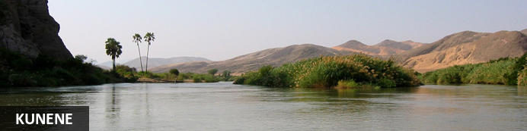
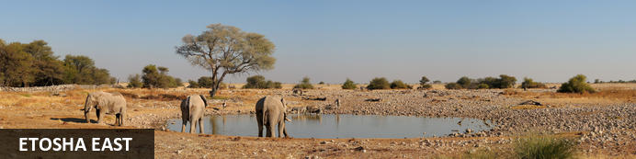
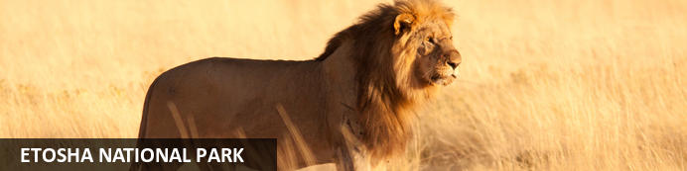
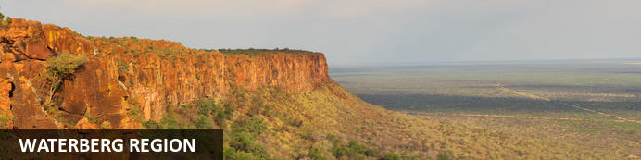
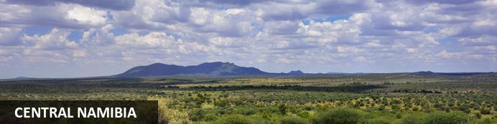

Cultural tour
Windhoek - Erongo Mountains - Twyfelfontein - Opuwo - Etosha East - Waterberg Region
10 Days / 9 Nights

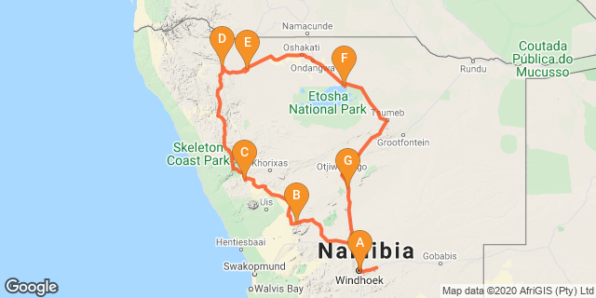

Introduction

Accommodation | Destination | Basis | Duration
Olive Grove Guesthouse | Windhoek | B&B | 1 Night
Ai Aiba Rock Painting Lodge | Erongo Mountains | D,B&B | 1 Night
Twyfelfontein Country Lodge | Twyfelfontein | D,B&B | 1 Night
Opuwo Country Lodge | Opuwo | D,B&B | 2 Nights
Uukwaluudhi Safari Lodge | Opuwo | D,B&B | 1 Night
Etosha King Nehale | Etosha East | B&B | 2 Nights
Otjiwa Safari Lodge | Waterberg Region | D,B&B | 1 Night

Key
B&B: Bed and Breakfast. D,B&B: Dinner, Bed and Breakfast

Price per person is NAD55,500.00 min 2 pax

Includes travel documentations
Toyota Fortuner or similar – unlimited km

Day 1: Olive Grove Guesthouse, Windhoek

Windhoek
WINDHOEK
Windhoek, the capital of Namibia, is located in a basin between the Khomas Highland, Auas and Eros Mountains. It is 1,680m above sea level, 650km north of the Orange River and 360km from the Atlantic sea. Whether due to pure luck or a brilliant stroke of Germanic planning, the city is situated in almost the countries epicentre. This location has obvious benefits when it comes to governing a country the size of Namibia, and also makes it the ideal place to start and plan any Namibian travel.
The majority of tourists visiting Namibia start their adventure in the capital as it is the main entry point to the country.
In 2013 the population of Windhoek was approximately 342,000 people, an extremely small capital by global standards. This number is growing rapidly at present mostly due to a lack of employment in rural areas. Despite the large increase in population over the last few years the city centre is extremely clean, and mostly trouble free. Most tourists comment on the cleanliness of the city, and often pronounce it to be a most un-African city (a somewhat back-handed compliment).
The city centre is characterized by a proliferation of German style buildings, a lasting reminder of Namibia's early colonial history. Early buildings such as the1890s Alte Feste (Old Fort), the sandstone Lutheran Christi’s Church, the Tintenpalast (seat of Namibia’s government), and the Parliament Gardens are of particular interest. Just west, past leafy Zoo Park, the Post Street Mall shopping walkway has a meteorite display. North is the Owela Museum of natural history and ethnography. The nearby National Art Gallery of Namibia showcases works by local artists. The Trans Namib Museum, in Windhoek Railway Station, explores the country’s transport history. Northwest is the diverse Katutura suburb, with its markets and local taverns known as shebeens. Further west, Daan Viljoen Game Reserve is home to kudu antelope, zebras and rich birdlife.
In a wonderful display of irony, the Alte Feste Fort, once the bastion of German colonialism, now houses the National Museum which places particular emphasis on the freedom struggle and Namibian independence.
Windhoek has had several names, many inspired by the hot water springs found in the area, the earliest of which were the Damara /Ais //Gams (/ indicates a click in Nama spelling) which means firewater and the Herero Otjimuise or place of steam. The area was also called Queen Adelaide's Baths for a (mercifully) brief time. Several opinions are offered for the origin of the present name, the most popular of these is that sometime before 1840 Jonker Afrikaner, a Nama leader, named the area Winterhoek, after the farm in South Africa where he was born. Windhoek, or windy corner, is a corruption of this name.
During the day the city centre has a European cafe culture, German cuisine dominates, but Namibian influence can be found in the quantity and quality of meat on offer. Saying that, the streets are choc-a-bloc with people of all ages and cultures, all bearing a wonderful sense of pride, hope and ambition.
Nightlife in the city centre has grown with the population, with a decent amount of restaurants, bars and night clubs.
Most importantly Windhoek is home to Namibia's brewing industry, and for the less active Windhoek is a great place to while away the time while sipping (or gulping) a cold beer. There are also a number of private hospitals, a state run hospital, and doctor’s surgeries, banks, (with 24 hr ATM's) pharmacies, supermarkets, bakeries, and clothes shops. There is a large(ish) shopping mall at Maerua Mall, (complete with indoor swimming pool and gymnasium) and a smaller one on Post Street Mall, (Town Square) and at Wernhill Park, all worth a visit, especially if you've had enough of looking at curios. Windhoek's (and Namibia's) sense of progress since Independence, is emphasized by the presence of new offices, combined with expanding and bustling building and commerce industries.

Overnight: Olive Grove Guesthouse
Olive Grove is a small upmarket accommodation establishment situated close to the city centre in a quiet, peaceful area. The Olive Exclusive, the guesthouse takes homely atmosphere to a different level. Recently completely refurbished, each room has been decorated and painted with new colour schemes allowing a different feel, but with the same elegant and simplistic emphasis on décor. The newly renovated, open-plan kitchen allows guests to see how meals are prepared, while they enjoy a drink in the lounge. The menu was also reinvented and is now fully a la carte, quite unique for a guesthouse. Home-style food is rounded off with great presentation, pushing up the level of the guesthouse dining experience. The upper deck has been revamped into a private dining corner, with two Moroccan-style sections, for guests to get comfy on the large pillows and enjoy the ambience and view from the top. The on-site Wellness Room offers a selection of professional services, to assist guests on their journey towards inner and outer well-being. Whilst each of the ten rooms and one suite cater for every need of the most discerning traveller, the emphasis remains one of simplicity and elegance.
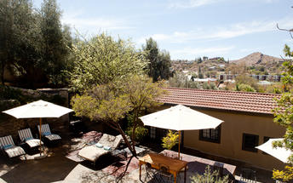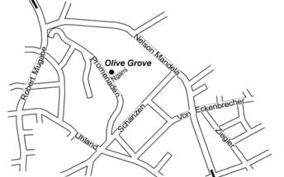

Activities
Cultural City Tour – optional for NAD850.00 per person

Basis
Bed and Breakfast

Day 2: Ai Aiba Rock Painting Lodge, Erongo Mountains

Erongo Mountains
Conveniently located only a few hour’s drive from Namibia’s capital city of Windhoek, the Erongo Mountain range stretches across the plains between the towns of Omaruru and Karibib, and is home to a remarkably rich natural heritage. This expanse of rugged wilderness serves as one of Namibia’s most popular tourist drawcards, attracting visitors with its spectacularly scenic landscapes; magnificent caves and rock painting sites; and its impressive array of wildlife species. These include, among others: rhino, elephant, cheetah, leopard, giraffe, wildebeest, impala, blesbok, waterbuck, kudu, warthog, mountain zebra, oryx, eland, springbok and over 200 species of bird. Visitors can look forward to enjoying a variety of adventurous activities such as hiking, rock climbing, games drives, horseback safaris and mountain biking.

Overnight: Ai Aiba Rock Painting Lodge
Set afoot massive granite rock boulders, overlooking the magically beautiful Erongo mountain range, is Ai Aiba - The Rock Painting Lodge. The overwhelming panoramic view from the restaurant and bar is amazing. The crystal clear pool invites you to refresh and relax. Your view sways leisurely over the endless landscape. Here you can enjoy the tranquility and purity of Africa. Ai Aiba is an active member of the Erongo Mountain Nature Conservancy, an association of farmers dedicated to the protection and preservation of the unique fauna and flora, as well as the magnificent granite landscape of the Erongo.
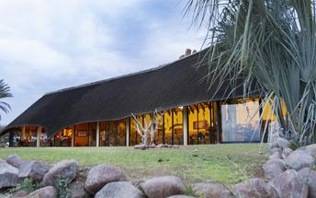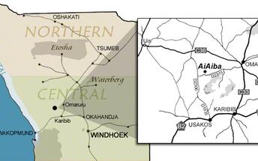

Activities
San Living Museum Tours – optional NAD650.00 per person

Basis
Dinner, Bed and Breakfast

Day 3: Twyfelfontein Country Lodge, Twyfelfontein

Twyfelfontein
Twyfelfontein is a site of ancient rock engravings in the Kunene Region of north-western Namibia.

Overnight: Twyfelfontein Country Lodge
The Lodge is situated in the heart of the Twyfelfontein Uibasen Conservancy and boast 56 en-suite twin rooms, reception, lounge, curio shop, open dining room, bar and swimming pool. In construction utmost care was taken to reduce the visual impact on the environment and to blend into the mountainside with the use of thatch roofs, natural stone and paint colors toning in with the surrounding rock formations.
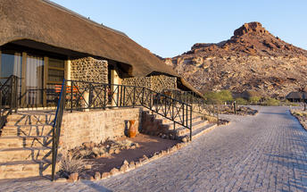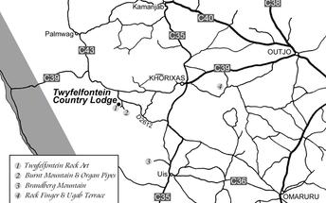

Activities
Damara Living Museum – optional NAD650.00 per person

Damara Living Museum
Observe and experience the traditional Damara way of life right in the heart of their traditional homelands. A unique opportunity to see a way of life that is slowly dying out. Open daily.

Basis
Dinner, Bed and Breakfast

Day 4: Opuwo Country Lodge, Opuwo

Opuwo
Opuwo, meaning 'the end' in Herero, lies in the north western Kunene region of Namibia. It serves as the capital of the region and is known as the gateway to the magnificent Epupa Falls. The surrounding landscape is characterised by low-lying hills, and vast dry desert plains inhabited by a wealth of desert-adapted wildlife. It serves as the central hub for the Himba culture. The town provides a perfect base for visitors wishing to explore the Kaokoland area and visit the local villages of the itinerant Himba people. The town and the Opuwo surrounding area is known as one of the cultural highlights of a trip to Namibia as it features an incredibly rich cultural heritage. Don’t miss an opportunity to learn about the fascinating Himba community within this starkly beautiful landscape.

Overnight: Opuwo Country Lodge
Opuwo Country Lodge is situated on a northwest facing hilltop just outside the town of Opuwo. An awe-inspiring 360º view of the surrounding area gives visitors a spectacular vantage point of the surrounding area. With luxury and standard accommodation, air conditioning, as well as well-appointed camping sites — the Lodge is the ideal base from which to explore the Kaokoland. Deck chairs and umbrellas set the scene for a relaxed day around the pool or a welcome respite from the heat after a hard day's drive. Next to the pool is the Bar and Restaurant where guests can enjoy ice cold refreshments and mouth-watering meals. The lodge is within easy reach of Kaoko-Otavi, Epupa Falls and Swartbooisdrift, popular destinations for visitors to the area. Road conditions between Kamanjab and Opuwo are in excellent condition (tarmac). The 85 km to Ruacana is also a tarmac road and in excellent driving condition. Fly-in guests are welcome. Please be sure to arrange for pickup before your arrival. The lodge is unfortunately not suitable for guests in wheel chairs.
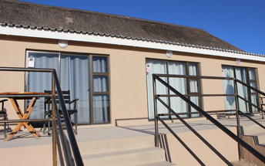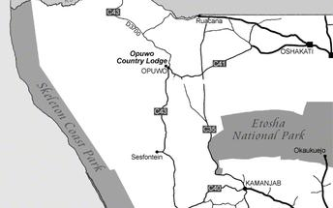

Basis
Dinner, Bed and Breakfast

Day 5: Opuwo Country Lodge, Opuwo

Activities
The Ovahimba excursion – optional NAD950.00 per person

The Ovahimba excursion
Located between the Ovahimba capital Opuwo and the paradisiac Epupa Falls at the Kunene River, The Ovahimba excursion is a place where guests can interactively experience the traditional culture of the Ovahimba people. The Museum consists of a large traditional homestead in which the Ovahimba introduce guests to their daily routines and encourage them to take part. Important elements include food, craftsmanship, the building of clay huts as well as singing and dancing.

Basis
Dinner, Bed and Breakfast

Day 6: Uukwaluudhi Safari Lodge, Opuwo

Overnight: Uukwaluudhi Safari Lodge
A setting of total tranquillity awaits the visitor, the main building and each of the 13 rooms that is strategically positioned on the hillside offer uninterrupted panoramic views over the large savannah plains, periodically dotted by antelope, zebra and giraffe that graze along the fringes of the surrounding Mopani and Terminalia woodland. The lodge offers 12 luxury en-suite twin rooms and 1 family unit with two bedrooms each with an en-suite bathroom.
The thatched main building, with a modern African-chic interior offers a lounge, bar, restaurant and boast a large wooden deck and swimming pool with breath-taking views over the landscape and the nearby
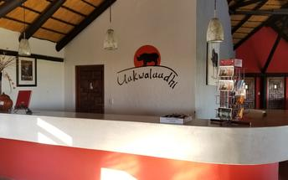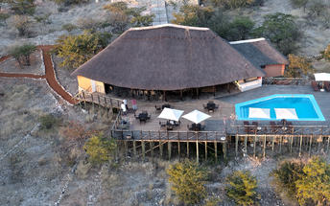

Activities
Uukwaluudhi Royal Homestead visit – optional NAD750.00 per person

Basis
Dinner, Bed and Breakfast

Day 7: Etosha King Nehale, Etosha East

Etosha East
In the vast arid space of Northern Namibia lies one of Southern Africa’s best loved wildlife sanctuaries. The Etosha National Park offers excellent game viewing in one of Africa’s most accessible venues. Zebra and springbok are scattered across the endless horizon, while the many waterholes attract endangered black rhinoceros, lion, elephant and large numbers of antelope. Etosha, meaning ‘place of dry water’, is encloses a huge, flat calcrete depression (or pan) of about 5 000km². The ‘Pan’ provides a great, parched, silver-white backdrop of shimmering mirages to an area of semi-arid savannah grassland and thorn scrub. The pan itself contains water only after very good rains and sometimes for only a few days each year, but is enough to stimulate the growth of a blue-green algae which lures thousands of flamingos.

Overnight: Etosha King Nehale
Etosha King Nehale is an exciting development that forms part of the Gondwana Collection Namibia and opened on 10 June 2020, about 5km north of the King Nehale Gate on the northern border of Etosha National Park.
Etosha King Nehale will host 40 rooms, which will pay homage to the rich cultural heritage of the area. The lodge is situated in the King Nehale Conservancy. The area is characterised by vast and spectacular landscapes including the Andoni Plains, artesian springs and woodlands. To the north, the conservancy is surrounded by the pulsating life of the communal areas of the Oshikoto, Oshana, Ohangwena and Omusati Regions.
Some of the property facilities will include a veranda with private splash pool, Wi-Fi available as well as a restaurant and bar. Guests have the opportunity to combine the cultural vibrancy of so-called Owamboland with the natural wonders of the rarely frequented northern part of the Etosha National Park.
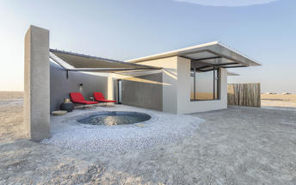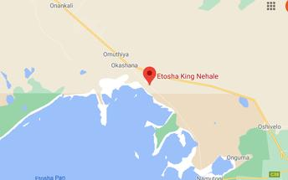

Activities
Nakambale Museum – optional NAD350.00 per person

Nakambale Museum
Nakambele Museum is located 13 kilometres southwest of Ondangwa. It is a legacy of the Finnish Missionaries who brought Christianity to Namibia and was founded by Martti Rautanen who was nicknamed Nakambale by the locals. Guided tours of the house, church and cemetery- which comprise of the museum are available.

Basis
Bed and Breakfast

Day 8: Etosha King Nehale, Etosha East

Activities
Etosha Game Drive – guest pay park entrance fee and drive themselves into the park

Etosha Game Drive
Etosha’s definitive feature is the Etosha Pan, a vast shallow depression, about 5 000 sq km in size. Classified as a saline desert, the expansive white plain of dry water is an unusual setting for game and that which sets Etosha apart from other reserves in Africa. On some days the pan is a shimmering sheet of mirages upon which the animals appear to be floating. A total of 114 animals are represented in the park, including several rare and endangered species such as black rhino and black-faced impala. Etosha’s elephants are reputed to be the largest in Africa, the tallest measuring up to 4 metres at the shoulder. Lion, wildebeest, zebra, cheetah, leopard, giraffe and many others are also seen in the park.

Basis
Bed and Breakfast

Day 9: Otjiwa Safari Lodge, Waterberg Region

Waterberg Region
Waterberg Plateau Park
This mountainous area owes its name to the springs found on the lower reaches of the mountain. Also found in this area are dinosaur tracks and petrified dunes. Waterberg Plateau Park (41 000 ha) was proclaimed as a park in 1972 for the purpose of protecting, breeding and maintaining populations of rare and endangered animal species in Namibia. (Since the proclamation, many endangered species including both Black and White Rhino, Buffalo, Roan and Sable antelope have been successfully relocated to this region where their survival is now ensured.) A Rhenish mission station was established at the Waterberg in 1873, later destroyed during Nama/Herero wars and rebuilt again in 1891.

Overnight: Otjiwa Safari Lodge
Otjiwa is one of the most diverse Namibian destination and not only an stop-over or gateway en-route the world famous Etosha National Park and Damara- or Kaokoland in the west or the Water-berg Plateau in the east. Otjiwa Safari Lodge offer much more than our unique and fragile nature that vary from savannah to acacia forest. Otjiwa enhance animal welfare of not only some endangered and several rare species as as well as an tremendous bird life collection. We encourage also day visitors to share our interest in Game drives, Angling, Canoeing, Mountain biking, Star Gazing, Hiking Swimming and Rhino tracking. Otjiwa sets the stage for unique romantic Weddings, Team Building, other special events and Conferences. Our superb restaurant serves gourmet dishes as well as a variety on excellent home-style Namibian meat.
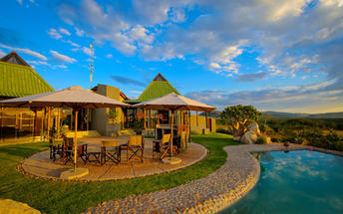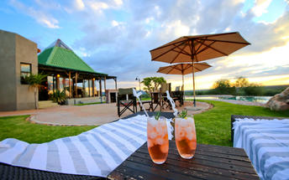

Activities
Ombu Village – optional NAD450.00 per person

Ombu Village
Ombu Village is placed on Farm Ombu on the way to Okonjima Nature Reserve in Namibia. The village seeks to document and preserve the heritage and culture of the Ovaherero in the form of a living museum, reflecting on the past whilst informing the present. Consisting of a traditional homestead, the village comprises 9 houses with distinctive original designs and building methods dating back to 1880, and other periodic designs over the last 150 years. An on-site curio shop offers a variety of Ovaherero traditional, handcrafted arts and crafts items which are bought from artisans in nearby villages.

Basis
Dinner, Bed and Breakfast

Day 10: End of Itinerary

Basis
Bed and Breakfast

